**Project 4: Matrix Multiplication**

Hao Wu

5140219226

May 16, 2017

Instructor: Ling Gong

1. Object:

Write a program that calculates the matrix multiplication with all the situation considering. You can see the detail in the end of chapter 4 of OPERATING SYSTEM CONCEPTS WITH JAVA(Seventh Edition), page 162…

1. Screen Cut:

We utilizing mutli-thread technic to calculating matrix multiplication. In this project, we can choose input matrix A and B as we need, only should satisfy the number of column of A is the same as the number of row of B. The calculating is using float, so don’t worry about the forced-type transition.

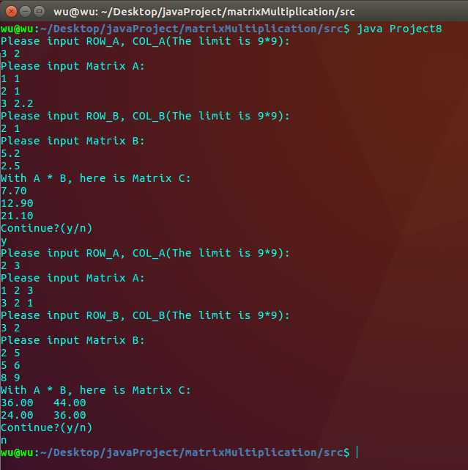

**Fig1 Simple shell interface**